**Project Report**

**ONLINE EXAMINATION SYSTEM**

**Submitted by**

**Muhammad Sami**  (2020-uam-2176)

**Muhammad Zain ul Aabedin** (2020-uam-2180)

**Adil Ali**  (2020-uam-2169)

(2020-2024)

**Supervised by**

**Dr. Aamir Hussain**



**INSTITUTE OF COMPUTING**

**MNS-UNIVERSITY OF AGRICULTURE, MULTAN**

**PAKISTAN**

**FINAL APPROVAL**

This is to certify that we have read this report submitted by ***Muhammad Sami, Muhammad Zain ul Aabedin, Adil Ali*** and it is our judgment that this report is of sufficient standard to warrant its acceptance by MNS-University of Agriculture, Multan for the degree of BS (Information Technology).

***Committee:***

1. **External Examiner ______________________**

Dr. Muhammad Sanaullah

Associate Professor

Department of Computer Science

Air University, Multan

1. **Supervisor ________________**

Dr. Aamir Hussain

Assistant Professor,

Institute of computing

MNS-University of Agriculture, Multan

.

1. **Head of Department ________________**

Dr. Salman Qadri

Professor/Director

Institute of Computing

MNS-University of Agriculture, Multan

**DECLARATION**

This is to certify that ***Muhammad Sami(2020-uam-2176), Muhammad Zain ul Aabedin(2020-uam-2180), Adil Ali (2020-uam-2169),*** Session (2020-2024) have worked on and completed their software project “***Online Examination System****”* at the Institute of Computing/IT, MNS-University of Agriculture, Multan, in partial fulfillment of the requirements for the degree of BS (Information Technology).

***Date: _____________***

Signature: _____________________

**Muhammad Sami**

**Reg. No. 2020-uam-2176**

Signature: _____________________

**Muhammad Zain ul Aabedin**

**Reg. No. 2020-uam-2180**

Signature: _____________________

**Adil Ali**

**Reg. No. 2020-uam-2169**

**DEDICATION**

We dedicate this effort to Almighty Allah, thank you for the guidance, strength, power of mind, protection and skills and for giving us a healthy life. Our great teachers Parents and messenger **Hazrat Muhammad (PBUH)** who taught us the purpose of life. This is whole heartedly dedicated to our beloved parents, who continually provide their spiritual, emotional, and financial support. Our respected Teachers and Friends who have been our source of inspiration and gave us strength when we thought of giving up, who encourage and support us to finish this**.**

**ACKNOWLEDGMENT**

ALLAH THE ALMIGHTY, who gave us the strength to work to complete this project on time and with the best possible quality and our family and friends who supported us in every step of life and mostly the past four years of university life. We would like to thank and sincerely acknowledge the help of our supervisor **Dr. Aamir Hussain** whose complete guidance, support and encouragement gave us a real motivation in doing this project. We would like to thank all the volunteers who helped us out while testing of this application. Lastly, we would like to thank all the faculty members of Institute of Computing for their help, time, and support that were gladly given to us on the time of need.

**PROJECT BRIEF**

|  |  |
| --- | --- |
| PROJECT NAME | Online Examination System |
| UNIVERSITY NAME | Muhammad Nawaz Sharif University Of Agriculture,  Multan |
| UNDERTAKEN BY | Muhammad Sami  Muhammad Zain ul Aabedin  Adil Ali |
| SUPERVISED BY | Dr. Aamir Hussain |
| STARTING DATE | 1 February, 2024 |
| COMPLETION DATE | 28 May, 2024 |
| COMPUTER USED | Core i5, Minimum 5th generation with minimum 252 SSD |
| OPERATING SYSTEM | Windows 11 Enterprise |
| SOURCE LANGUAGE(S) | Python |
| TOOLS/PACKAGES | MS Office, VS Code |
|  |  |
|  |  |
|  |  |
|  |  |

**PLAGIARISM UNDERTAKING**

I solemnly declare that the work presented in the report titled “***Online Examination***

***System***” is solely our work with no significant contribution from any other person. Small contribution/help wherever taken has been duly acknowledged and that complete report has been written by us.

I understand the zero-tolerance policy of the HEC and MNS-University of Agriculture, Multan towards plagiarism. Therefore, I as an Author of the above titled report declare that no portion of my report has been plagiarized and any material used as reference is properly referred/cited.

I undertake that if I am found guilty of any formal plagiarism in the above titled report even after award of the degree, the University reserves the rights to withdraw/revoke my degree and that HEC and the University has the right to publish my name on the HEC/University Website on which names of students are placed who submitted plagiarized report.

Student /Author Signature: ______________

Name: __________________

# ABSTRACT

Our Project (Online Examination System) is basically a Web base Application. The Examination System for university is an essential component of the academic administration process. It plays a crucial role in streamlining and automating the result generation, processing, and dissemination tasks. The proposed Examination System incorporates several key features to address the challenges faced by traditional manual result management systems. These features include online result submission, automated result processing, secure data storage, and real-time result dissemination to students and faculty members. Through the implementation of the Online Examination System, College and university can achieve various benefits. 1) The system significantly reduces the time and effort required for result generation and processing, eliminating manual errors and delays. 2) It offers a centralized platform for faculty members to securely submit student remarks, ensuring accuracy and consistency. 3) The Examination System provides real-time access to students, enabling them to view and save their results. The Examination System serves as a valuable tool for college and universities to streamline their academic administration processes, ultimately benefiting both faculty members and students.

**Table of Contents**

ABSTRACT viii

Chapter 1 1

INTRODUCTION 1

1.1 Project Introduction 2

1.2 Main Theme 2

1.3 Scope of the Project 2

1.4 Objectives of the Project 3

1.5 Introduction to Organization 3

Chapter 2 4

BACKGROUND 4

2.1 Existing System (Literature Review) 5

2.2 Gaps (Deficiencies) in Existing System 5

2.3 Proposed Solution 6

Chapter 3 7

SPECIFICATION & DESIGN 7

3.1 Data Gathering 8

3.2 Introduction to System Specification 9

3.2.1 Functional Requirement 9

3.2.2 Non-Functional Requirement 11

3.3 Introduction to System Design 12

Use Case Diagram 12

Data Flow Diagram 15

Entity Relationship Diagrams (ERDs) 15

SYSTEM DEVELOPMENT & IMPLEMENTATION 17

4.1 Tool/Language Selection 18

4.2 Hardware for the System 18

4.3 Clients-Side Technology 18

4.4 Servers-Side Technology 18

Chapter 5 19

USER’S GUIDE 19

5.1 User Interface 20

Teacher Add Course Info: 28

Chapter 6 19

CONCLUSION & FUTURE WORK 39

**Figures:**

Figure 1: Use case Diagram ................................................................................................ 13

Figure 2: Flow Chart ........................................................................................................... 14

Figure 3: Data Flow Diagram .............................................................................................. 15

Figure 4: ERD ..................................................................................................................... 16

Figure 5: Dashboard Online Exams system……................................................................. 20

Figure 6: Admin Panel ........................................................................................................ 21

Figure 7: Dashboard ............................................................................................................ 22

Figure 8: Admin Control Section ......................................................................................... 23

Figure 9: Admin view Section ............................................................................................. 24

Figure 10: Teacher Section .................................................................................................. 25

Figure 11: Teacher Signup ……........................................................................................... 26

Figure 12: Teacher Dashboard….......................................................................................... 27

Figure 13: Course Addition .................................................................................................. 28

Figure 14: Student Enroll .................................................................................................... 29

Figure 15: Student login ....................................................................................................... 30

Figure 16: Student login Dashboard ..................................................................................... 31

Figure 17: Exams …………….............................................................................................. 32

Figure 18: Enter the Examination…...................................................................................... 33

Figure 19: Result ………........................................................................................................34

Figure 20: Result Details .......................................................................................................35

Figure 21: System LogOut.....................................................................................................36

Figure 22: Coding portion......................................................................................................37

Figure 23: Coding Portion.....................................................................................................38

# Chapter 1

# INTRODUCTION

Chapter 1 Introduction

## 1.1 Project Introduction

The Examination System is a crucial component of any educational institution, especially universities. It plays a vital role in efficiently managing and processing student results, ensuring accuracy, security, and ease of access. To streamline this process, a Web base Application for **Online Examination System** is developed, providing a user-friendly interface for administrators, faculty, and students to manage and access academic results.

## 1.2 Main Theme

Developing a desktop application for a university offers benefits such as streamlined processes, increased accuracy, time and effort savings, enhanced accessibility, improved security, scalability, customization, integration with existing systems, and offline functionality. These advantages contribute to efficient system and a better overall experience for university staff involved in managing and processing student results.

## 1.3 Scope of the Project

User Management: The system should have user roles and permissions, allowing admin, teacher, and students to access specific functionalities based on their roles.

**Result Entry:**

Faculty members should be able to enter and manage different courses and exams. The system should provide an interface for inputting grades, marks, or scores.

**Result Publication:**

At the time of ending exams the results are finalized and verified, the system should provide a mechanism to publish results securely. Students should be able to view their individual results online.

**Result Archive:**

The system should maintain a historical record of all results, allowing access to previous semesters' data for reference and analysis purposes.

Chapter 1 Introduction

**Communication and Notifications:**

The system should facilitate communication between faculty members, administrators, and students regarding result-related matters. It should provide notifications for published results, grade changes, or any other relevant updates.

**Integration with Student Information System (SIS):**

Ideally, the result management system should integrate with the university's existing student information system to synchronize student data, course information, and registration details.

**Security and Data Privacy:**

The system should prioritize security measures to protect student data and ensure compliance with data privacy regulations.

## 1.4 Objectives of the Project

* Efficient Data Management
* Accuracy and Transparency
* Timely Result Publication
* Customization and Flexibility
* Student and Faculty Engagement
* Compliance and Security
* Integration with Other Systems:
* Scalability and Reliability • Continuous Improvement

## 1.5 Introduction to Organization

Online Examination System in a university contributes to a more efficient, transparent, and student centric academic environment. It optimizes administrative processes, supports data-driven decision-making, enhances student success, and strengthens the overall quality of education provided by the university.

# Chapter 2

# BACKGROUND

Chapter 2 Background

## 2.1 Existing System (Literature Review)

Documentation: In a manual system, results are recorded on physical result sheets or mark sheets, which are time-consuming to create, distribute, and collect. These physical documents need to be stored and maintained physically, leading to storage challenges and the risk of damage or loss.

**Error-Prone:**

Manual data entry and calculations are prone to human errors, such as recording incorrect grades or miscalculations. These errors can have a significant impact on the accuracy of result records and may require additional efforts to rectify.

**Limited Accessibility:**

Students need to physically visit the university or designated office to collect their result sheets. This may cause delays, inconvenience, and challenges for students who are unable to access the university premises in a timely manner.

Data Security: Physical result sheets can be vulnerable to unauthorized access, loss, or tampering. Maintaining the confidentiality and integrity of student records can be challenging in a manual system.

## 2.2 Gaps (Deficiencies) in Existing System

* Manual and Paper-based Processes
* Lack of Automation
* Limited Transparency and Accessibility
* Security and Data Integrity Concerns
* Inefficient Communication Channels
* Limited Customization and Adaptability
* Inadequate Reporting and Analytics

Chapter 2 Background

## 2.3 Proposed Solution

• **Automation:**

A web base online examination system automates the result management process, eliminating manual paperwork and reducing the time and effort required for result compilation, calculation, and publication. It streamlines the process and ensures accuracy and consistency.

* **Efficiency and Time-saving:**

With a Online examination system, the result management tasks are automated, significantly reducing the time required for result compilation, calculations, and record-keeping. The system can generate results quickly and efficiently, saving administrative effort and allowing timely result publication.

* **Data Accuracy:**

A desktop application minimizes the risk of data entry errors and miscalculations as most processes are automated. It ensures accurate recording of grades and calculations, reducing the need for manual verification and correction.

* **Enhanced Accessibility:**

Online examination system provide online portals or dashboards where students can access their results from anywhere, anytime, using their login credentials. This enhances accessibility and convenience for students, as they can view their results without physically visiting the university.

* **Data Security:**

A Online examination system can implement robust security measures to protect student data, such as user authentication, access controls, and encryption. It provides a more secure environment for storing and managing student records, reducing the risk of unauthorized access or data loss.

# Chapter 3

# SPECIFICATION & DESIGN

## 3.1 Data Gathering

We used questionnaire technique to gather data about our project Online Examination System. We analyze data provided by Administration and Examination Controller office of MNSUAM, and College and try to solve according to our requirement.

**3.1.1 Questionnaires**

We use different Questionnaires for Admin, Faculty and Student.

**Questionnaire for Faculty Members:**

1. What is your role in the result management process?
2. How do you currently submit student marks? Please describe the existing process.
3. What challenges do you encounter in the current examination system?
4. What features or functionalities would you like to see in a new examination system?
5. How do you prefer to access and review student results (e.g., online, mobile, desktop)?
6. How important is data security and privacy in the examination system?
7. What measures should be in place to protect student data?

**Questionnaire for Students:**

1. How do you currently access your results? Describe the existing process.
2. Are you satisfied with the current result dissemination methods? Why or why not?
3. What features or functionalities would you like to have in a new examination system?
4. How important is real-time access to your results?
5. How do you prefer to receive notifications or updates regarding your results (e.g., email, SMS, online portal)?
6. Would you like to have access to historical result data (e.g., past semesters, academic years)?
7. What concerns do you have regarding the security and privacy of your result data?

**Questionnaire for Administrative Staff:**

1. What is your role in the examination system process?
2. What are the current challenges or inefficiencies in the examination system?
3. What data do you need to capture or validate during the result entry and approval process?
4. How do you currently communicate and collaborate with faculty members and students regarding result-related matters?
5. Are there any specific reporting requirements or data analytics needs for result analysis and decision-making?
6. What features or functionalities would you like to see in a new result management system to enhance your administrative tasks?
7. How important is data accuracy and integrity in the examination system?
8. What measures should be in place to ensure efficient data processing and minimize errors in the system?

**3.1.2 Sampling & Observations**

We divide the university population into strata based on departments, faculties, or academic programs. Then, select participants from each stratum to ensure representation from different areas of the university. Then observe the existing result management process in action, noting the steps involved and observe the interactions between faculty members, administrative staff, and students during the result submission, review, and dissemination stages. Conduct focus group discussions with faculty members, administrative staff, and students to explore their experiences, perspectives, and opinions regarding the existing examination system. Organize user feedback sessions where faculty members, administrative staff, and students can test prototypes or mockups of the new examination system. Analyze the collected data from sampling, observations, focus group discussions, and user feedback sessions to identify common themes, patterns, and issues in the existing examination system.

## 3.2 Introduction to System Specification

### 3.2.1 Functional Requirement

**User Management:**

* Allow Teacher, and students to register and create user accounts in the system.
* Define different user roles (e.g., administrator, faculty, and student) with specific access permissions to perform various management tasks.

**Result Entry and Submission:**

* Enable faculty members to submit student marks electronically.
* Perform data validation checks to ensure accuracy and consistency in result entry, such as checking for valid grade scales, prerequisites, and credit hours.

**Result Dissemination:**

* Make student results available online in real-time once they are processed and finalized.
* Ensure that students can securely access their own results through authenticated user accounts.
* Provide notification mechanisms (e.g., email, SMS) to inform students about the availability of new results or updates.

**Result Review and Approval:**

* Allow faculty members to review and modify submitted results before final approval.
* Implement an approval workflow where authorized personnel can review and approve results, ensuring quality control and accuracy.

**Data Analytics and Reporting:**

* Enable users to create custom reports with specific result data filters and parameters.
* Allow access to historical result data for analysis and comparison purposes.

**Integration and Data Exchange:**

* Integrate the examination System with the university's Student information system to retrieve student information and synchronize data updates. .

**Security and Privacy:**

* Implement secure user authentication mechanisms (e.g., username and password, two-factor authentication) to ensure only authorized users can access the system.
* Apply data encryption techniques to protect sensitive student information during storage and transmission.
* Enforce role-based access control to restrict user access to specific functionalities and data based on their roles and permissions.

### 3.2.2 Non-Functional Requirement

**Performance:**

* The system should provide quick response times, ensuring that users can access and interact with the system without significant delays.
* The system should be able to handle a large volume of concurrent users and process result data efficiently, especially during peak times (e.g., result publication periods).
* The system should be highly reliable, minimizing downtime and ensuring uninterrupted access to result data.

**Usability:**

* The system should have an intuitive and easy-to-use interface, allowing users to navigate and perform tasks with minimal training or assistance.
* The system should be accessible to users with disabilities, complying with accessibility standards and guidelines.

**Security and Privacy:**

* Implement robust security measures to protect sensitive student information from unauthorized access, tampering, or breaches.
* Regularly backup result data and have mechanisms in place to recover data in the event of system failures or disasters.

**Integration:**

* System Integration: Enable seamless integration with other university systems, such as Student Information Systems (SIS) or Learning Management Systems (LMS), to exchange data and ensure data consistency across platforms.

**Performance Monitoring and Reporting:**

* Implement monitoring mechanisms to track system performance, detect anomalies, and proactively address issues.
* Maintain detailed logs of user activities and system events for audit purposes and troubleshooting.
* Provide administrative staff with reporting capabilities to monitor system usage, identify usage patterns, and gather insights for system optimization.

**System Maintenance and Support:**

* Provide comprehensive documentation, including user manuals, system administration guides, and troubleshooting resources, to assist users and system administrators.
* Offer timely technical support and assistance to users and system administrators to address their queries, issues, or system-related concerns.
* Plan for regular system upgrades and enhancements to incorporate new features, address issues, and keep the system up-to-date with evolving requirements.

## 3.3 Introduction to System Design

**3.3.1 System Design using UML**

Designing a result management system using UML (Unified Modeling Language) involves capturing the system's structure, behavior, and interactions.

### 

### Use Case Diagram:

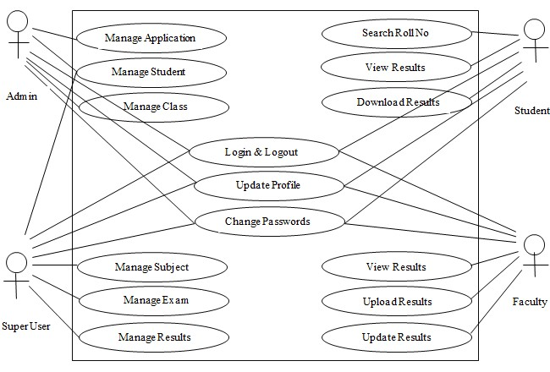

**Figure 1**

**Start**

**Login**

**Check User Level**

**Check**

**Permission**

**Check**

**Permission**

**Check**

**Permission**

**Check**

**Permission**

**Manage Student**

**Manage Class**

**Manage Subject**

**Manage Result**

**Logout**

**Figure 2**

#### End

### Data Flow Diagram

**Teacher Management**

**Login Management**

**ONLINE**

**EXAMINATION**

**SYSTEM**

**Admintrative Management**

**Student Management**

Home Section

**Figure 3**

### 

### Entity Relationship Diagrams (ERDs)

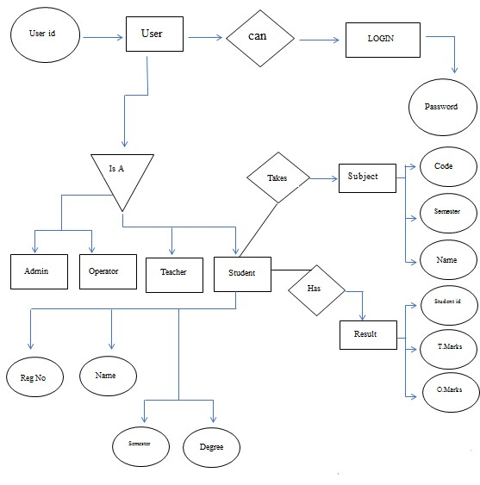

# Figure

**Chapter 4**

# SYSTEM DEVELOPMENT & IMPLEMENTATION

Chapter 4 System Development & Implementation

## 4.1 Tool/Language Selection

* VS Code
* Language: Python
* Framwork: Django

## 4.2 Hardware for the System

* Core i5
* Minimum 5th generation with minimum 252 SSD
* SSD: 252 SSD

## 4.3 Clients-Side Technology

1. It is web technology that provide the Python Django framework for developing web online examination system on the Windows platform. It uses a drag-anddrop interface to design the application's user interface and utilizes Python as the programming language.

## 4.4 Servers-Side Technology

Python Django: This is a popular server-side framework developed in Python. It is widely used for building web applications and can be used for desktop applications as well. Python provides a rich set of libraries and tools for data processing, authentication, and server-side logic.

# Chapter 5

# USER’S GUIDE

## 5.1 User Interface

**Dashboard Online Exams system:**



**Figure 5**

**Admin Panel:**

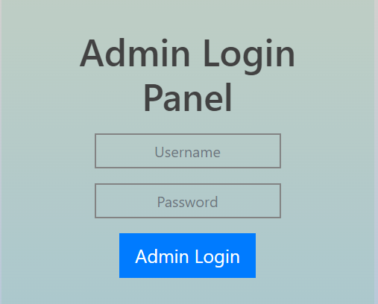

**Figure 6**

**Admin Dashboard:**

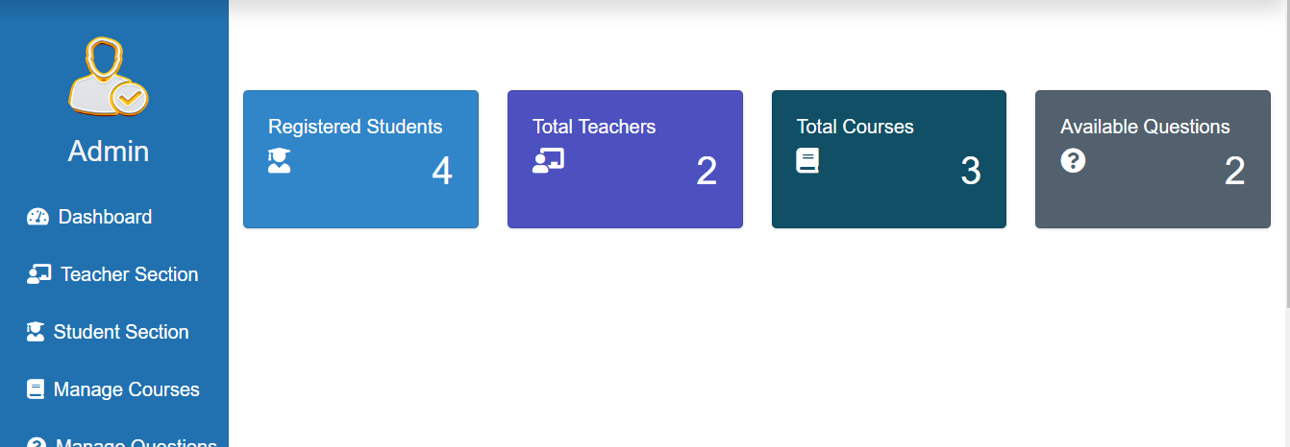 **Figure 7**

**Admin Control Section:**

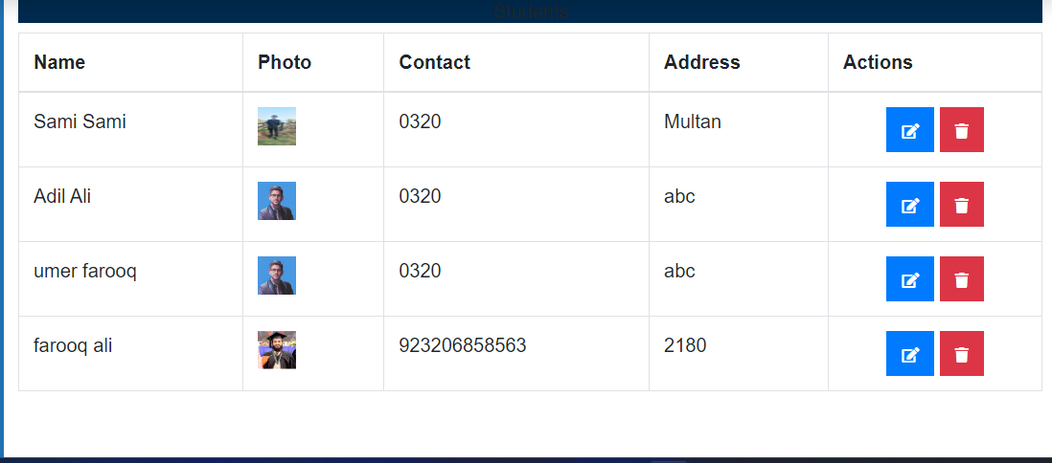 **Figure 8**

Admin View courses:

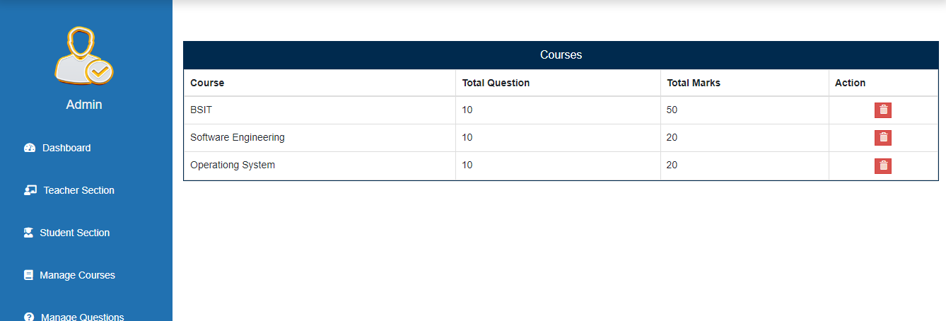 **Figure 9**

**Teacher Section:**

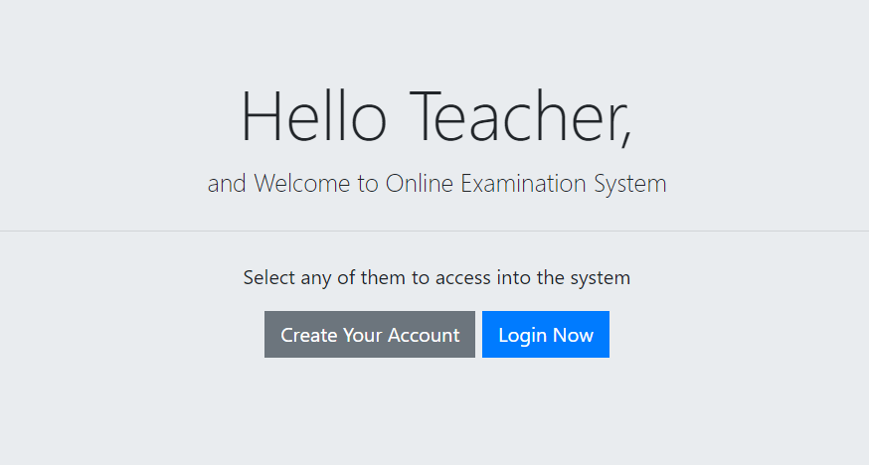 **Figure 10**

**Teacher Signup Form:**

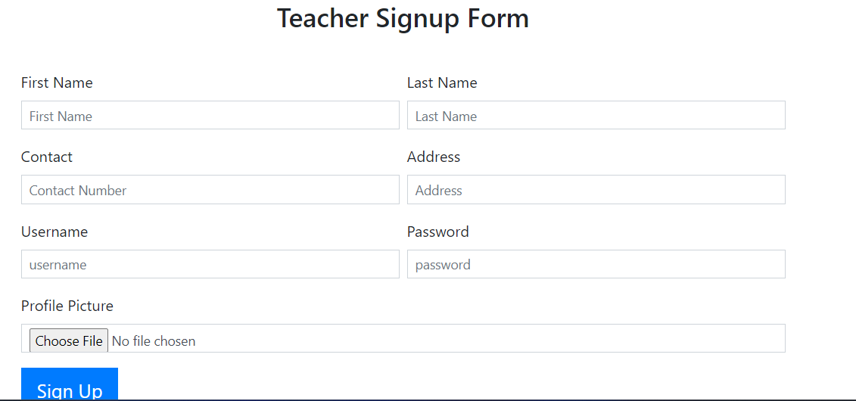 **Figure 11**

**Teacher Dashboard:**

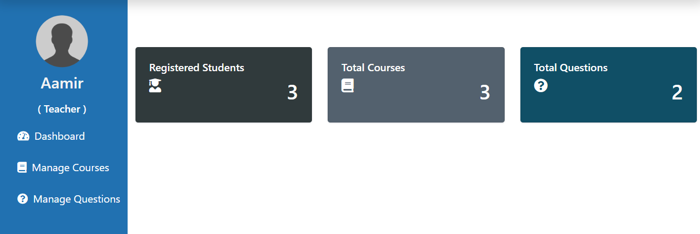 **Figure 12**

## 

## Teacher Add Course Info:

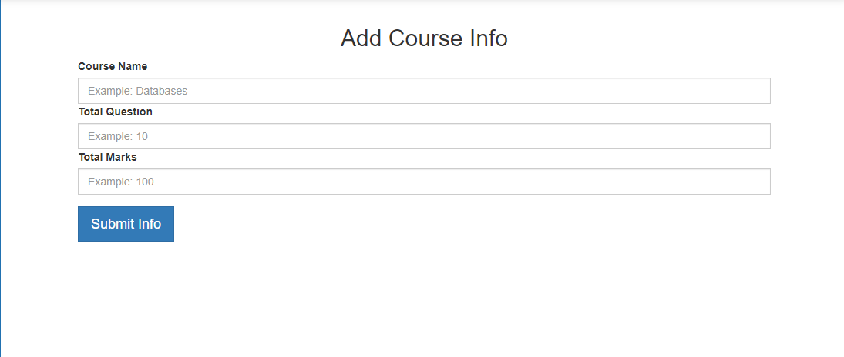 **Figure 13**

**Student Signup Form:**

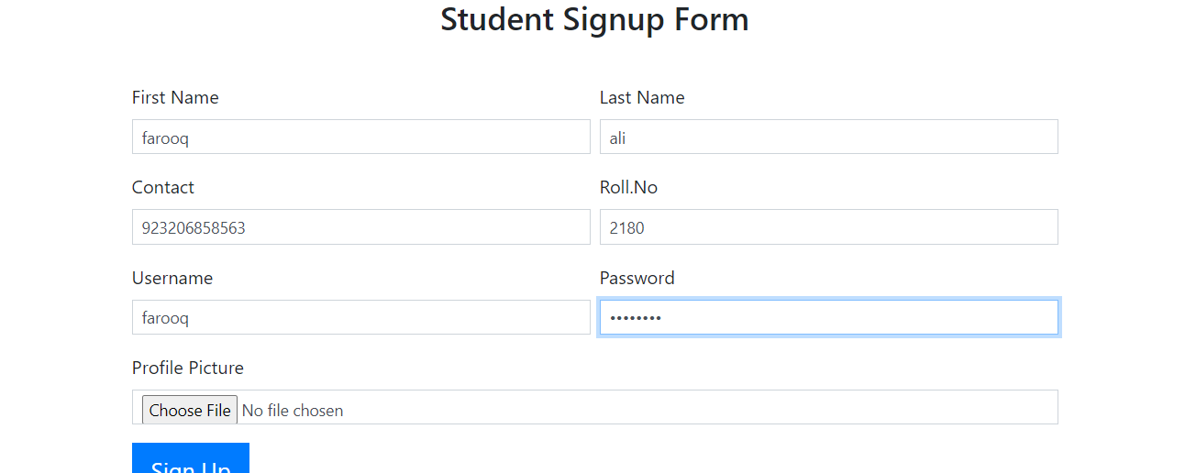 **Figure 14**

**Student Login Form:**

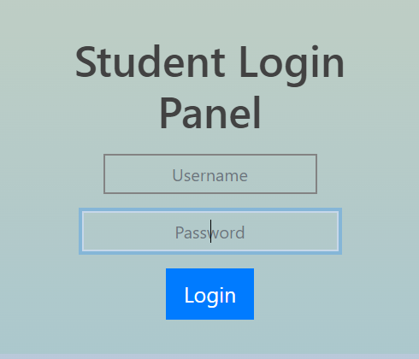

**Figure 15**

**Student Dashboard:**

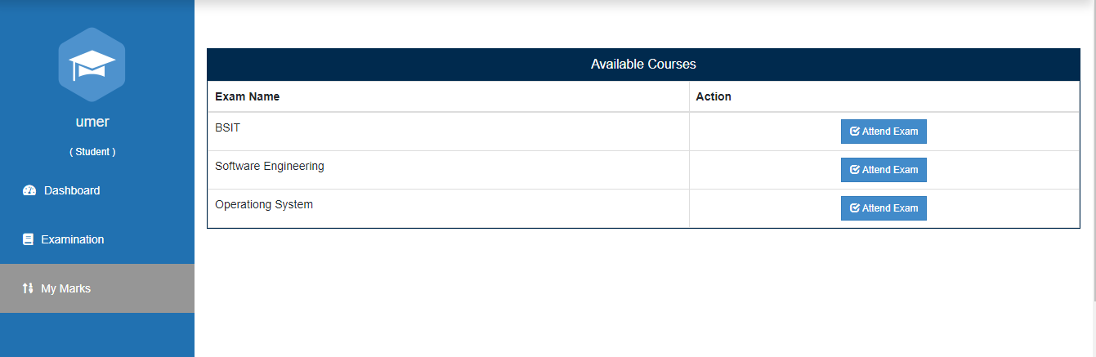 **Figure 16**

**Exams:**

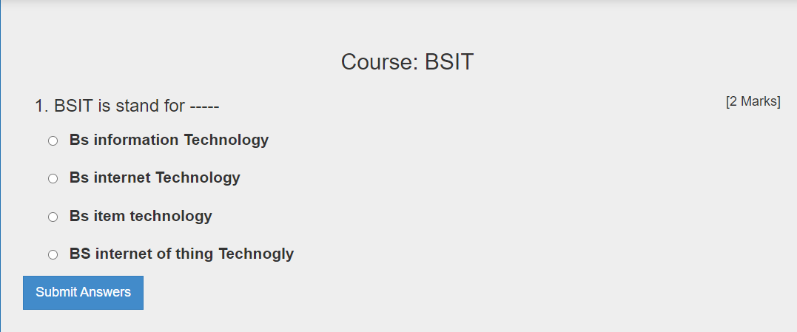 **Figure 17**

**Exams Enternece:**

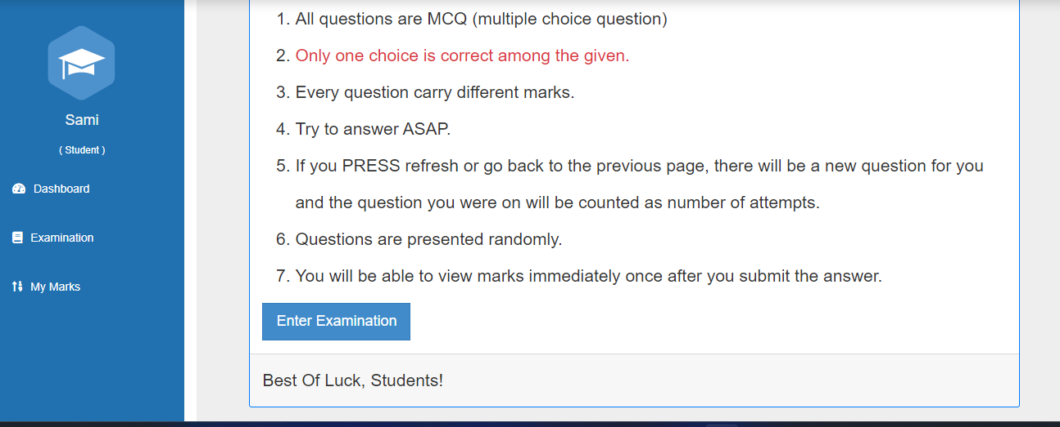 **Figure 18**

**Exams Marks:**

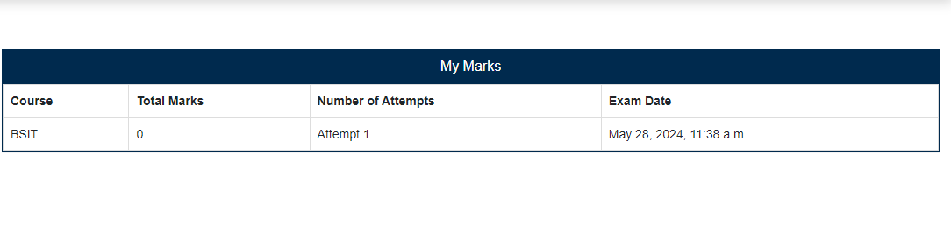 **Figure 19**

**Student Mark View Option:**

 **Figure 20**

**Logout System:**

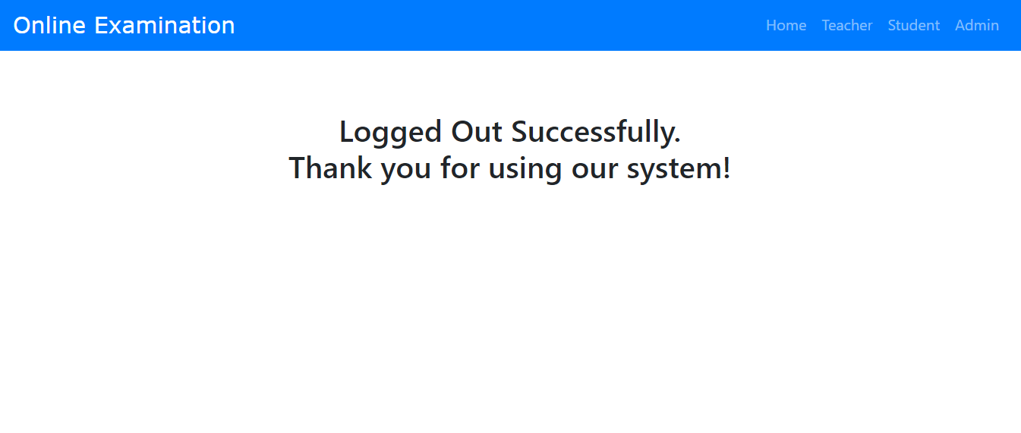 **Figure 21**

**Coding Interface:**

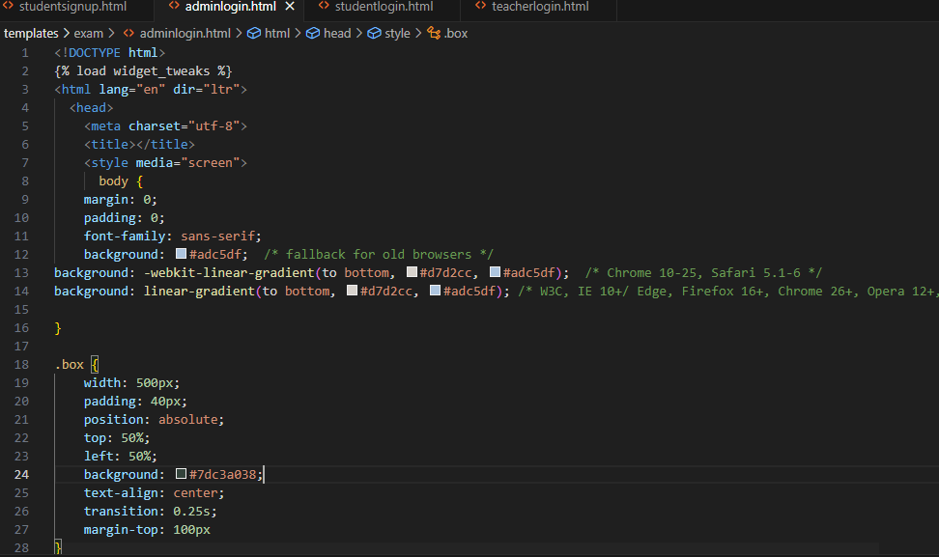

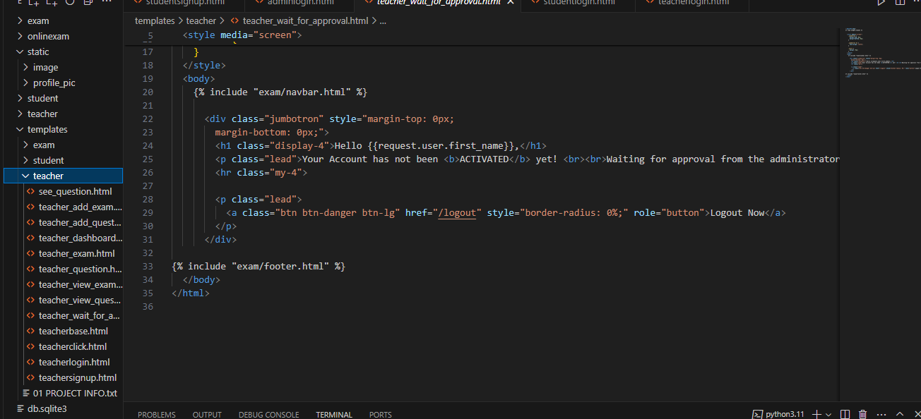

**Chapter 6**

# CONCLUSION & FUTURE WORK

Chapter 6 Conclusion & Future Work

The implementation of an Online Examination system for a university offers numerous benefits and improves the overall efficiency and effectiveness of result management processes.

The system streamlines and automates various tasks, leading to reduced administrative burden and improved accuracy in result processing.

The Examination system provides a centralized platform for storing, accessing, and managing student results, eliminating the need for manual record-keeping and paperwork. This enhances data security, minimizes the risk of data loss or manipulation, and ensures easy retrieval of result information whenever required.

The system enables faster result processing, reducing the time taken for result compilation, verification, and publication. This not only enhances student satisfaction but also allows academic staff to focus on other essential tasks such as curriculum development, teaching, and research.

END